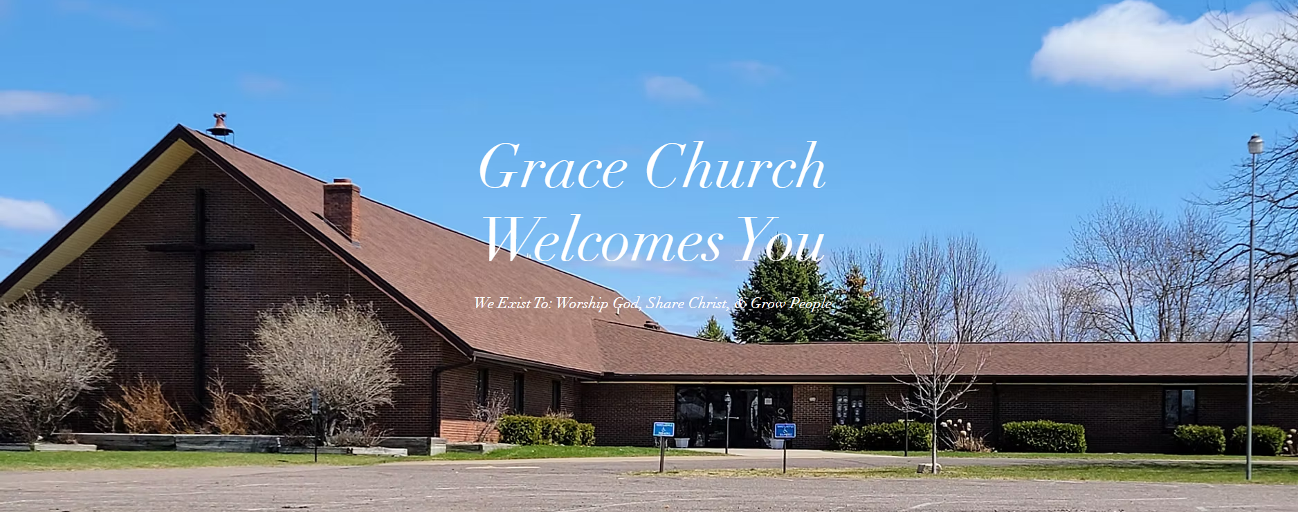

Who We Are
We are a Biblically based, Christ centered, family of believers who gather to fellowship, serve and worship God. Our mission is to glorify God by creating an atmosphere in which people can begin and enjoy a personal relationship with Christ, mature in Christ's likeness and worship Christ in life changing ways. Our most important goals are summed up in our mission statement: “We exist to Worship God, Share Christ, and Grow People”; in short, to fulfill Christ’s Great Commission.
Job Description
- We desire a pastor with strong communication skills who is able to Teach and Preach the Word of God effectively.
- We are seeking someone able to effectively communicate to both those who are far from Christ as well as to those who are more mature in their walk with the Lord.
- We are looking for a pastor who will help us create a vision to develop and equip our congregation to take the church out into our community.
- Above all, we hope for lives to be transformed by the Gospel of Jesus Christ in our church and throughout our community.
Our History
Grace Baptist Church history dates back to 1869, when Swedish immigrants arrived to settle in the area circling out from the intersection of Highway 70 and Williams Road, a couple of miles east of Grantsburg. The Wood River Swedish Baptist Church was incorporated August 15, 1869 with their building ready for Christmas, 1870.
In 1871 several members who lived in the Village of Grantsburg began a Sunday School. On September 24, 1884, the First Swedish Baptist Church of Grantsburg was organized and in 1887 the church was built on West Wisconsin Avenue. The two congregations continued to cooperate, especially around missions. As the years passed, other nationalities became members so both churches dropped Swedish from their names.
In the early 1960's a merger began with the two churches and plans were made for a new building to be built in the Village of Grantsburg. The new combined congregations chose the name Grace Baptist Church and incorporated May 13, 1964. The first service at Grace Church was held on June 15, 1969.

Today
Grace Church is situated set in a prominent location near the intersection of Highway 70 and Highway 87/48 in the Village of Grantsburg, right on the main route through town. Our congregation has served our community at this location for over 60 years, and recently celebrated our 150th anniversary. We have a strong past, and we look forward with joy to the future things the Lord will do with this church in this community and for His Kingdom.
The Village of Grantsburg is positioned along the Wood River. It has a dam on the edge of town that forms the body of water known as Memory Lake. The Wood River continues west and south and flows into the St. Croix River. This corner of Northwest Wisconsin is known as a destination area for outdoorsmen and women, with a multitude of lakes, rivers, forested areas, and rural communities. Grantsburg is touted as a place where you can ‘work and fish, all in the same day’, with excellent hunting, fishing, ice fishing, hiking, canoeing, swimming, boating, camping, water skiing, cross country and downhill skiing, ATV and snowmobiling opportunities nearby.
Grantsburg is just a few miles from the Crex Meadows Wildlife Area. This is one of the largest wildlife areas in Wisconsin. Grantsburg is known as the “Gateway to Crex Meadows”. Crex Meadows is a birding and wildlife viewing ‘mecca’, boasting more than 280 species of birds, 720 species of plants and over 96 species of butterfly as well as a wide variety of reptiles, amphibians and insects, along with the occasional moose. Crex Meadows along with the St. Croix National Scenic Riverway provide thousands of acres of public land to enjoy and explore.
Each year the community hosts a town celebration, Big Gust Days, named for a prominent citizen, Gust Anderson. The 7-1/2 foot tall giant became well known as the village Marshall and lamp lighter. A statue of him is on display in front of the old hospital and library. The Grantsburg area is also known for the World Champion Snowmobile Watercross, which is held downtown at the Memory Lake park the third weekend in July each summer.
The attractive beauty that includes our community is just the start. Grantsburg is also the industrial hub of Burnett County. With easy access to Minneapolis/St Paul, small town charm, and a friendly atmosphere, Grantsburg is the spot to be!

How to Apply
Contact:
Brian Petersen
Pastoral Transition Coordinator
Converge Great Lakes
bpetersen@convergegreatlakes.org

